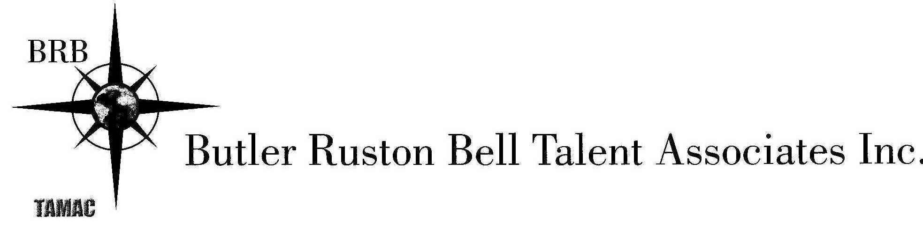

DIANA COFINI
ACTRA, EQUITY
Hair: Dark Brown Eyes: Brown WEIGHt: 108 lbs dianacofini.com
FILM & TV
REIGN Lady Monique Ducasse CW Network/Dir. Holly Dale
WE (Pre-Production) Lead Actra Co-op/Dir. Mani Nasry
LACRIMOSA (Pre-Production) Lead The NE Inc./Dir: Chris Strikes
REVELATION (Post-Production) Lead Cofini Productions/Armistice Films/Dir: Ryan Boyko
NIKITA Actor Nikita Films/Dir: David Solomon
IN BETWEEN DREAMS Supporting Chrysalis Productions/Dir: Mark Orzulak
FAT CHANCE Principal HBO Canada/TMN/Dir: Beatrice Yuste
LITTLE FILMS ABOUT BIG MOMENTS Self HBO Canada/TMN/Dir: Dominika Dittwald
VERONA Gamma Girl Appulse Films/Dir: Laurie Lynd
T.O to D.C: The Journey to Self 1LoveT.O. Prods./Dir: Chris Strikes
BARACK Obama’s Inauguration
CLONES Lead MTV/Much Music Prods./Dir: Ali Rizvi
TESTEES Actor FX Productions/Showcase/Dir: Ian MacDonald
CUPID’S CAFÉ Lead Hop To It Prods. Inc./Dir: Paul Hart
TWENTYSOMETHINGTV.COM (5 episodes) Self Brett Heard Prods./Dir: Brett Heard
WATCHING Lead Retro Vertigo Prods./Dir: Daniel Warth

SELECTED THEATRE
Masquerade/THE HOTEL PLAY (upcoming) Nadia (Lead) Beattie Theatrical Productions Ltd./ Dir: Douglas Beattie
PIE IN THE SKY Rosie (Lead) Milton Theatre for the Performing Arts/Dir: Douglas Beattie
PIE IN THE SKY Rosie (Lead) The Tarragon Theatre/Dir: Douglas Beattie
IT’S A WONDERFUL LIFE Violet/Zuzu/Various The Canadian Stage Company/Dir: Donna Feore
THE MAID’S TRAGEDY Aspatia Theatre Erindale Mainstage/Dir: Patrick Young
EMBER (Solo show) Ember DNA Theatre/Dir: Erin Klee
ORPHEUS DESCENDING (Solo show) Lady/Val/Various Theatre Erindale Junior Project/Dir: Diana Cofini
DIPLOMATIC IMMUNITIES Company/Co-Creator Mammalian Diving Reflex/Dir: Darren O’Donnell
RADIUM GIRLS Various Roles Theatre Erindale Mainstage/Dir: Ralph Small
BELLE STORYTIME Belle Fantasy Fables Inc./Disney/Dir: Cindy Long
THE DISPUTE Adine Theatre Erindale Mainstage/Dir: Mimi Mekler
BEAUTY AND THE BEAST Belle Fantasy Fables Inc./Disney/Dir: Cindy Long
JASMINE Jasmine Fantasy Fables Inc./Disney/Dir: Cindy Long
THE IMMIGRANT YEARS Company/Co-Creator Theatre Erindale Mainstage/Dir: Alex Fallis
PAPER TRAILS Katie Theatre Erindale Fringe/Dir: Skye Plowman

RADIO
SOUNDS OF THE SEASON Singer/Radio Player CBC Radio One/Glenn Gould Studio/CanStage

PRINT, VOICE OVER, COMMERCIAL & INDUSTRIAL
LIST AVAILABLE UPON REQUEST

EDUCATION & SELECTED TRAINING
Honors Diploma in Acting Sheridan College
Honors Bachelor OF Arts University of Toronto (Theatre Specialist, Political Science Minor)
Honors Gr. 8 Singing & Piano Royal Conservatory of Music
Honors InterMEDIATE Jazz & Ballet Canadian Dance Teachers Association
BALLET & DANCE (ALL STYLES) Christina Pora-Balaceanu Classical Ballet Academy
SINGING (ALL STYLES) Marie Baron, Kyra Millan, Annalisa Ovcharenko, John Carr, Donald Horsburgh
MUSICAL THEATRE Kristin Hanggi (Rock of Ages), Donald Horsburgh (Citadel Theatre)
MICHAEL CHEKHOV ACTING TECHNIQUE MICHA NYC: Ragnar Freidank, Scott Fielding, Marjolein Baars, Phelim McDermott
SCRIPT ANALYSIS & CHARACTER WORK Patrick Young, Laurence Follows
SHAKESPEAREAN TEXT Ron Cameron-Lewis
PERIOD MOVEMENT/STYLES Ralph Small, Dennis Hayes, Ron Cameron-Lewis, Sarah-Jane Burton
CLOWN & MASK Mimi Mekler, Teodoro Dragonieri
FIGHT CHOREOGRAPHY/Stage Combat Rapier Wit Academy: Daniel Levinson
Improvisation Michael Goran
On-Camera ACTING TECHNIQUE David Rotenberg, Janet-Laine Green, Dean Armstrong, Catherine McNally
COMEDY ON CAMERA Marc Bowden, Jamie Lamb, Kurt Smeaton, Brett Heard
VOICE OVER WORKSHOPS Mike Kirby, Debra Toffan

AWARDS
Arthur Lindsay Fernie BURSARY Outstanding Performance, Lead Role of “Adine”: The Dispute/Theatre Erindale
the Canadian Stage Company AWARD Excellence in Drama, Lead Role of “Alison”: You Are Here/St. Joseph’s S. S.

SPECIAL SKILLS
Languages: Fluent Italian, Conversational French, Can perform in Spanish. Italian Citizen (Dual CAN & EU Passport), Various Accents/Dialects

